20th and 18th and 17th and 16th and 15th November 2024 and 6th October 2024

Dear Siva Kumar Murugadoss,

Thanks for inviting me to meet you at Spraoi today at a quarter to five o’clock when I telephoned you at 12:12 today.

Unfortunately I do not detect adequate progress by Helen McEntee and Fine Gael. I am a witness about 3 murders because of Fine Gael. These murders happened because I was tortured. Permanent physical injuries used to be inflicted into me because Helen McEntee refuses to save me.

These Ministers for Justice in Fine Gael of the times (Helen McEntee; Charles Flanagan; and Simon Harris) can confirm that I repeatedly request them via registered letters and emails for international arrest warrants during many years. I still wait for even one arrest warrant.

The Language Commissioner can confirm that the staff of the Language Commissioner upholds a complaint by me that a response by Simon Harris about these would-be arrest warrants is illegal.

Clár na nÁbhar
Introduction 1
Police underperformance at Athboy and Navan 2
Slowness for a hate crime in Navan 2
Murders and crimes against humanity which preceded these murders on accounts of subvention frauds by DCU and QQI and an Irish embassy to Portugal 2
More Information about Portuguese Persecution 6
GSOC 7

Introduction
This email is about the International Criminal Court; the European Court of Human Rights; and the International Court of Justice about inter alia torture against me by Portugal in 2013; the consequential murders; persecution; and discrimination.

Please find attached copies of
Litir - CCI Cheist - 03.05.2023.pdf
and
of a draft of an article by myself about language discrimination by The Irish Jurist. The Irish Jurist is a scientific journal.

I refer below to translations which arrived on 18th and 20th November 2024. They include a translation of a document which caused 3 murders; torture; persecution; and permanent physical injuries in me.

Police underperformance at Athboy and Navan
I went to the police station to Athboy on 12/10/2024. It was closed. I pressed a button of a police communication device at this station on 12/10/2024. It seemed to attempt to telephone a different police station. It failed. It responded with an automatic error message only in English about a wrong number. So I went to the police station to Navan on the same day. I complained on 12/10/2024 to a policeman in Navan about this faulty communication device at Athboy’s police station.

I took a microphone to Athboy’s police station on 10/11/2024 when I recorded a repeat of exactly the same unacceptable error message. Cf.
HTTP://Gloucester.Insomnia247.NL/gardai/gardai_um_Bhaile_Atha_Bui/20241110_115511.mp4
Furthermore this button failed during this recording. Furthermore this button is too high such that a child attempting to flee from a paedophile would not be able to press it!

Slowness for a hate crime in Navan
I witnessed discriminatory persecutory hate crimes on a racist advertisement in SuperValu in Navan shortly before 4:40:50p.m. on 13/10/2024.

"Large
Room/Bedsit to Rent
Silver Tankard Area
€850 (bills inc.)*CASH PAYMENT ONLY
Irish Only (Midseptember Onward)
Tel.: 086 - 3908372"
says this advertisement.

A police car; policeman; and policewoman were in this car park then so I reported these crimes to them. This policewoman said that they needed to immediately leave because of an emergency. So I walked to Navan’s police station. This policewoman and this policeman walked into this police station whilst I made a statement to another policeman. This other policeman telephoned me on 14/10/2024 saying that he was travelling to SuperValu about this advertisement.

I used a camera to record this advertisement on 10/11/2024. Cf.
HTTP://Gloucester.Insomnia247.NL/gardai/ciniochas_ag_an_Uaimh/20241110_122300.mp4
A policeman or somebody else scribbled over “IRISH” after I complained but it is still legible and it continues to be criminal. When will this advertisement become confiscated? When will a court summon me to testify against it?

Murders and crimes against humanity which preceded these murders on accounts of subvention frauds by DCU and QQI and an Irish embassy to Portugal

Portugal murdered 2 of my friends and another neighbour to cover up torturing me in 2013. I want:
* the Republic of Ireland to prosecute Portugal at the International Court of Justice (
HTTPS://WWW.ICJ-CIJ.org
);
* the Republic of Ireland to prosecute Portugal at the European Court of Human Rights via an inter-state case ("ARTICLE 33

Inter-State cases

Any High Contracting Party may refer to the Court any alleged
breach of the provisions of the Convention and the Protocols
thereto by another High Contracting Party"
says
HTTPS://WWW.ECHR.COE.int/documents/d/echr/convention_eng
);
* the Republic of Ireland to demand the International Criminal Court to issue international arrest warrants against the persons who tortured me and against the persons who perpetrated the murders about which I am a witness;
* help about how to invoke this country's universal jurisdiction against torture (CRIMINAL JUSTICE (UNITED NATIONS CONVENTION AGAINST TORTURE) ACT, 2000 (
HTTPS://WWW.IrishStatuteBook.Ie/eli/2000/act/11/section/2/enacted/en/html#sec2
));
and
* documents of the Council of Europe to be translated to Irish and Portuguese including:
· there is still never an application form for the European Court of Human Rights in Irish! (
HTTPS://WWW.ECHR.COE.int/web/echr/apply-to-the-court-other-languages?filter_category_4580691=2035040
);
and
· the big reports by the European Committee for the Prevention of Torture and Inhuman or Degrading Treatment or Punishment (CPT) (which are published since 1994!) criticising Portugal over repeatedly violating international law are only in English and French (a coauthor of many of these reports works in Dublin).

Please find attached
International_Criminal_Court_is_a_Sham.2024-05-04d_with_name.doc
which is about murders and torture in Portugal which cites many times the aforementioned coauthor in Dublin and it also cites a lady with an Irish law degree.

The journal that is called the Irish Jurist (
HTTP://IrishJurist.com
) refuses to publish an article by me because it is in Irish. This discrimination is unacceptable. Cf. Attachment
LAC-S-24-00121.pdf

The website of the law firm that represents me in torture law is
HTTPS://PaisDoAmaral.Pt/contactos

Recordings of conversations with law firms about these murders are in
HTTP://Gloucester.Insomnia247.NL/Siva_Kumar_Murugadoss/

Recordings of conversations about these murders with European-Court-of-Human-Right employees who criminally rudely hung up are in HTTP://Gloucester.Insomnia247.NL/Denis_Lambert/

Attachment
Litir - CCI Cheist - 03.05.2023.pdf
is by an Irish conniving embassy in the Netherlands. This ambassador pretends that crimes against humanity are not crimes against humanity when they are perpetrated against my nationality! An Irish embassy in Portugal also connives. This embassy in Portugal and DCU and QQI and this country’s legal-aid boards caused this torture.

“At DCU we will not compromise on the quality and your degree will be highly regarded [. . .] internationally.”
says
HTTPS://WWW.DCU.Ie/connected/why-choose-dcu-connected
dishonestly. Contrast this boast with this pleading by a defendant in a document which is dated 13/07/2011 in e.g.
HTTP://Gloucester.Insomnia247.NL/Ricardo_Namora_de_Melo_Teixeira/2024-10-21/prioritised_documents/translations/2011-07-13_pleading_by_racist_defendants__Pages01-13__Translation3.docx

Contrast these lies with this transcript from Deaths Crimes Urine:
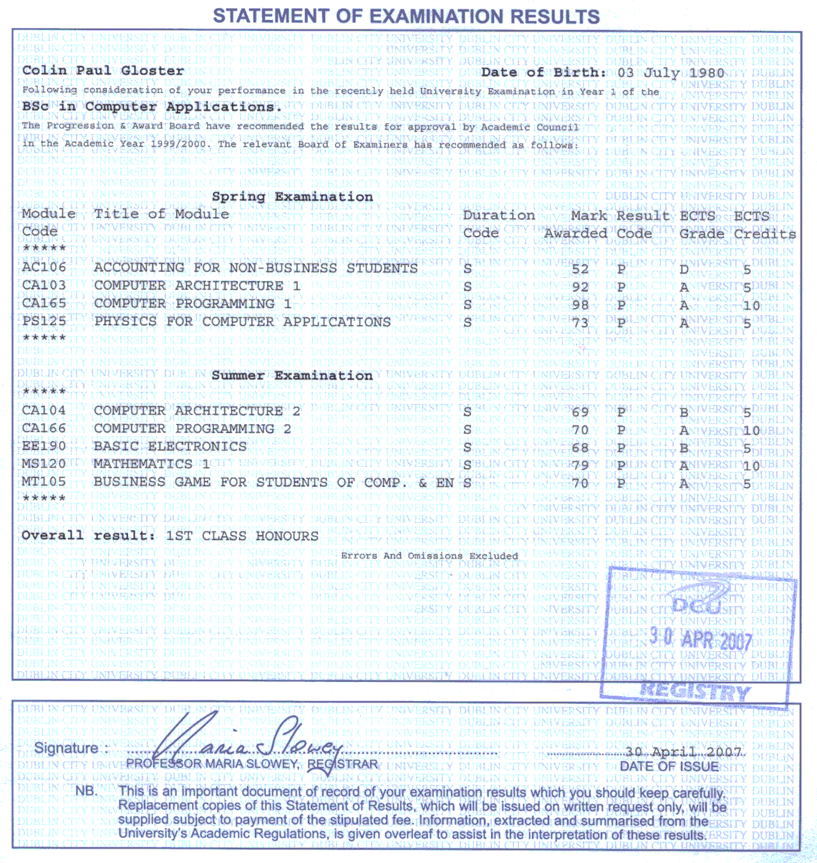
I apply to the putative Republic of Ireland for legal aids since 17/07/2015. On 15/11/2024 – nine years later! – an Irish Human so-called Rights and so-called Equality Commission wrote a self-contradictory refusal to grant me a legal aid in a mixture of English and broken Irish: “Is oth liom a chur in iúl duit gur chinn an Coimisiún gan cúnamh dlíthiúil a dheonú duit ar an bhforas nach n-ardaíonn an t-ábhar lena mbaineann na himeachtaí lena mbaineann ‘ceist phrionsabail’ chun críocha alt 40(4)(a). den Acht um Choimisiún na hÉireann um Chearta an Duine agus Comhionannas 2014.

The reasons
Breithníodh d’iarratas faoi na critéir chun cúnamh a dheonú de réir Alt 40 den Acht um Choimisiún na hÉireann um Chearta an Duine agus Comhionannas 2014. Tugann na Treoirlínte ar Iarratais ar Chúnamh faoi Alt 40 cur síos ar a bhfuil san áireamh agus cinneadh á dhéanamh maidir le hiarratas ar chúnamh dlíthiúil.

Is iad seo a leanas na cúiseanna atá le cinneadh an Choimisiúin gan cúnamh dlíthiúil a dheonú:
Ar bhonn na faisnéise a cuireadh ar fáil, ní nochtann na fíricí mar a nochtar cás láidir agus ní dócha go n-éireoidh le haon dlíthíocht atá beartaithe. Dá réir sin, ag féachaint d’alt 40 agus do Threoirlínte an Choimisiúin, ní ardaíonn an t-ábhar seo ‘ceist phrionsabail’ de réir bhrí dhlíthiúil alt 40(4)(a).
Tuigim gur ábhar díomá duit cinneadh an Choimisiúin gan cúnamh dlíthiúil a dheonú. Ar an drochuair, ní fhéadfaidh an Coimisiún cúnamh den sórt sin a sholáthar ach amháin nuair a chomhlíontar na critéir reachtúla ábhartha. Ba mhaith liom a aibhsiú, áfach, nach gciallaíonn sé sin nach n-aithníonn an Coimisiún dáiríreacht na saincheisteanna a ardaíodh ar do shon.”

This pleading in a document which is dated 13/07/2011 in e.g.
HTTP://Gloucester.Insomnia247.NL/Ricardo_Namora_de_Melo_Teixeira/2024-10-21/prioritised_documents/translations/2011-07-13_pleading_by_racist_defendants__Pages01-13__Translation3.docx
is clear discrimination and persecution! An obligation to grant me legal aids against Portugal is a matter of principle! E.g. this defendant lost a court case over a scholarship but it refuses to obey a court order to pay me tens of thousands of Euro.

More Information about Portuguese Persecution
The murders which I am a witness about are consequences of my torture which is a consequence of our persecution. (I am not the only Gaelic scientist whom Portugal perpetrates discrimination against.)

These files prove the persecution that caused my torture . . .
HTTP://Gloucester.Insomnia247.NLl/Ricardo_Namora_de_Melo_Teixeira/2024-10-21/prioritised_documents/translations/2011-xy-za_or_2012-xy-za_Parecer_juridico_-_estrangeiros_-_concurso_bolsas_2011_Translation2.docx
and
HTTP://Gloucester.Insomnia247.NL/Ricardo_Namora_de_Melo_Teixeira/2024-10-21/prioritised_documents/translations/2011-07-13_pleading_by_racist_defendants__Pages01-13__Translation3.docx
and
other documents (to be) in
HTTP://Gloucester.Insomnia247.NL/Ricardo_Namora_de_Melo_Teixeira/2024-10-21/prioritised_documents/translations/
and
different pages which I did not pay to translate.

If you would read them and would complain that translations are ambiguous or not clear or whatever, then a translator might rephrase them before I myself would pay for notarisation (which is not cheap).

GSOC

I submitted a complaint to a police ombudsman. Cf.
HTTP://Gloucester.Insomnia247.NL/gardai/2024-11-19a_gearan_ri_ombudsman_gardai_.odt
and
HTTP://Gloucester.Insomnia247.NL/gardai/2024-11-19b_gearan_ri_ombudsman_gardai__Lch3.pdf
and
HTTP://Gloucester.Insomnia247.NL/gardai/2024-11-19b_gearan_ri_ombudsman_gardai__Lch4.pdf
and
HTTP://Gloucester.Insomnia247.NL/gardai/2024-11-19b_gearan_ri_ombudsman_gardai__Lch5.pdf
and
HTTP://Gloucester.Insomnia247.NL/gardai/2024-11-19b_gearan_ri_ombudsman_gardai__Lch6.pdf
and
HTTP://Gloucester.Insomnia247.NL/gardai/2024-11-19b_gearan_ri_ombudsman_gardai__Lch8.pdf
and
HTTP://Gloucester.Insomnia247.NL/gardai/2024-11-19b_gearan_ri_ombudsman_gardai__Lch9.pdf
and
HTTP://Gloucester.Insomnia247.NL/gardai/2024-11-19d_Laistigh_den_tseachtain_seo_chugainn_seolfaimid_litir_chugat_ag_admhail.pdf
and
HTTP://Gloucester.Insomnia247.NL/gardai/2024-11-19e_submission__Lch2.pdf
and
HTTP://Gloucester.Insomnia247.NL/gardai/2024-11-19e_submission__Lch4.pdf
and
HTTP://Gloucester.Insomnia247.NL/gardai/

I redacted personal details about most of the witnesses whom I nominated to this ombudsman. Most of the witnesses would become murdered after the first few in Portugal would have testified. A form of this ombudsman does not enable nominating many witnesses. I can identify many many more witnesses than this form enables.

Is mise,
Nioclás Pól Caileán de Ghloucester

Cf. LAC-S-24-00121.pdf
More documents are in HTTP://Gloucester.Insomnia247.NL/Ricardo_Namora_de_Melo_Teixeira/2024-10-21/prioritised_documents/translations/
Cf. inter alia Newsgroups: ie.announce,ie.news.group,ie.general,ie.politics Date: Sat, 28 Jan 2023 16:24:44 +0100 Subject: Feabhsaígí cúnamh dlíthe Message-ID: <44739db7-8686-1e1-7e87-2da45cb2f297@insomnia247.nl>
Cf. this order of 27/11/2020 – HTTP://Gloucester.Insomnia247.NL/Ricardo_Namora_de_Melo_Teixeira/2024-10-21/prioritised_documents/2020-11-27_by_3_judges_ordering_payment_of_a_scholarship.pdf – for which I do not yet have a translation. (However Anglophone courts do have translations thereof.)

